Task 2: Cloud service Models.
1. List three popular apps you use (like Instagram, Zomato, or Spotify) and for each, identify whether it is most similar to IaaS, PaaS, or SaaS. Briefly explain your reasoning for each choice.
Ans
Cloud Service Model | Example | Reasoning
IaaS (Infrastructure as a Service) | Amazon EC2 (AWS) | Amazon EC2 provides virtual servers, storage, and networking. Users are responsible for installing and managing the operating system, applications, and data, while AWS manages the physical hardware and infrastructure.
PaaS (Platform as a Service) | Google App Engine | Google App Engine provides a platform for developers to build, test, and deploy applications without worrying about servers, operating systems, or infrastructure management. Google handles the underlying platform.
SaaS (Software as a Service) | Instagram | Instagram is a ready-to-use application accessed through a mobile app or web browser. Users simply use the service, while Instagram manages the software, servers, updates, and maintenance.

2. Create a table comparing IaaS, PaaS, and SaaS with at least three points for each model, using real-world examples such as AWS EC2, Google App Engine, and Office 365.
Ans:
Feature | IaaS (Infrastructure as a Service) | PaaS (Platform as a Service) | SaaS (Software as a Service)
Description | Provides virtual infrastructure such as servers, storage, and networking over the internet. | Provides a platform for developers to build, test, and deploy applications. | Provides ready-to-use software that users can access through the internet.
User Responsibility | Users manage the operating system, applications, and data. | Users manage only the application and data, while the provider manages the platform. | Users simply use the software; the provider manages everything else.
Main Benefit | Offers maximum flexibility and control over the infrastructure. | Makes application development faster by removing infrastructure management. | Easy to use with no installation or maintenance required.
Real-World Example | AWS EC2 (Amazon Elastic Compute Cloud) | Google App Engine | Microsoft Office 365
Typical Users | System administrators, IT teams, and cloud engineers. | Software developers and application development teams. | General users, students, and businesses.
3. Sign up for a free AWS account (or use an existing one), navigate to the EC2 dashboard, and launch a new t2.micro EC2 instance running Ubuntu 22.04. Take a screenshot of your running instance in the AWS console.<br><br><em><strong>Hint:</strong> Use the 'Launch Instance' button and select the free tier eligible Ubuntu AMI.</em>
Ans: The steps are:
- Go to the AWS Management Console and sign in.
- In the search bar, type EC2 and open the EC2 Dashboard.
- Click Launch Instance.
- Enter an instance name (e.g., Ubuntu-Server).
- Under Application and OS Images (AMI), select Ubuntu Server 24.04 LTS (Free Tier Eligible).
- Under Instance Type, choose t3.micro (Free Tier Eligible).
- Create a new key pair (or select an existing one) and download the .pem file if creating a new one.
- Under Network Settings, keep the default VPC and enable Allow SSH traffic (port 22).
- Leave the storage at the default 8 GiB gp3.
- Review the configuration and click Launch Instance.
- Wait 1–2 minutes until the Instance State changes to Running.
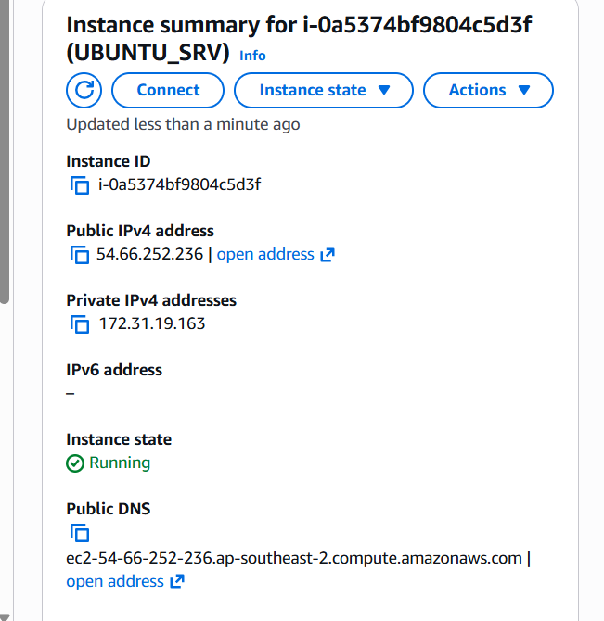
4. After your EC2 instance is running, connect to it using SSH from your local terminal or an online SSH client. Run the command 'uname -a' and note the output.<br><br><em><strong>Hint:</strong> You may need to use the .pem key file downloaded during instance setup.</em>
Note: All the Commands are in the Screeshots.
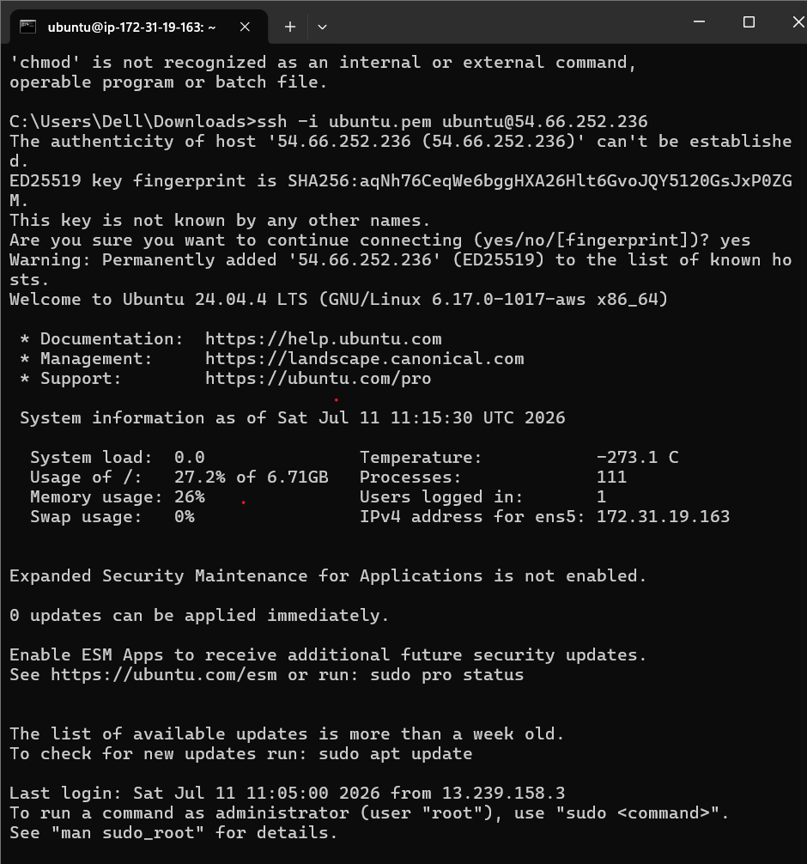

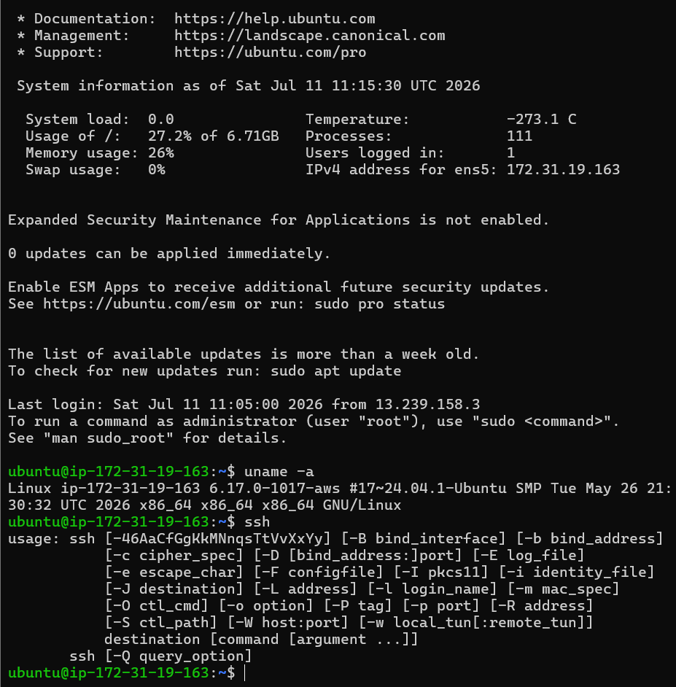

5. Suppose you want to host a simple static website for your college fest using your EC2 instance. List the basic steps you would follow after launching the instance to make your site accessible to everyone. Write 3-5 steps in order.
Ans: Note: All the Commands are in the Screeshots.
